Greenhithe School Stationery Requirements 2023
Year 2 Whole Year

*The following items must be individually named
 | Label with the following
1 x My Literacy Book 2 Warwick | 1st Writing book
2 x Writing – 1I5 Warwick Exercise Book (9mm) | 2nd & 3rd Writing Book
1 x Clever Kiwi “How to Write” | Handwriting 1
4 x F/S Expanding Cardboard Wallet* | Maths, Reading, Inquiry, Maori
2 x 20 Page Clearfile Display Books* (if you are new to Greenhithe School you need 3 display books) | Writing Publishing folder  Poem Folder  Portfolio (if new to Greenhithe School)
1 L Shaped clear plastic pocket* | Reading Log
2 x large Glue Stick
3 x Whiteboard Markers (black)
1 x boxes HB Staedtler Pencils (no rubber)
2 x Black Stephens Vivids
1 x Jovis pack (crayons)
1 x BIC Kids Cascade Felt Tip Markers assorted colours (12 pack)
1 Pencil sharpener
1 x Staedtler Eraser

Only purchase the brand of item stated above
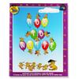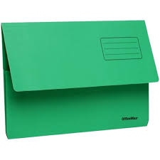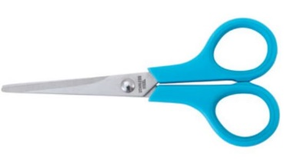

Stationery Packs can be ordered from the School Uniform Centre.

Stationery packs ordered from the School Uniform Centre in December/January will be couriered to you towards the end of January 2023

Telephone: 09 524 6270
Fax: 09 524 6272
Website: www.schooluniformcentre.co.nz

